Physics Stage 2: Motion and Force

Task 10: Test on Motion and Force

Name: ___________________________________________________ (40 marks)

- Thomas, a non-physics student, is asked by his mum to help push a car trailer out of the way. Thomas tells his mum that there is no point as Newton’s Third Law states that every force produces an equal and opposite force so if he pushes the car trailer, the car trailer pushes back so nothing moves. Explain Newton’s Third Law to Thomas and why he is able to push the car trailer out of the way. (3 marks)

Newton’s Third Law states that for every action force there is an equal but opposite reaction force. [1 mark]

The main concept here is that the two forces may be equal in size but they are not the same force as they are acting in opposite directions (force is vector). [1 mark]

As far as the trailer is concerned, the only force on it is from Thomas applying the force and so as long as his force is great enough, the trailer will move. Thomas finds the trailer hard to move as the trailer is applying a force onto him. [1 mark]

- An aircraft moves to the start of a runway at 6.00 ms⁻¹ and from this speed accelerates at 8.50 ms⁻² for 15.0 s until it takes off.
- What minimum length must the runway be? (2 marks)

s = ut + ½ at²
= (6.0 x 15) + (0.5 x 8.5 x 15²) [1 mark]
= 90 + 956.25
= 1046.25
s = 1.05 x 10³ m [1 mark]

- What is the takeoff velocity of the aircraft? (2 marks)

v = u + at
= 6.0 + (8.5 x 15) [1 mark]
= 6 + 127.5
= 133.5
v = 133 m s⁻¹ [1 mark]

- Simon is off to Mars for his holidays. (Mars has an acceleration due to gravity of 3.4 ms⁻²). His suitcase has a mass of 25.0 kg on Earth. Simon notices that his suitcase is always much easier to carry on Mars. Determine the mass and weight of Simon’s suitcase on Mars.
(3 marks)

mass = 25 kg F_{w} = mg
= 25 x 3.4 [1 mark]
[1 mark] F_{w} = 85.0 N [1 mark]

- Look at the following graph.
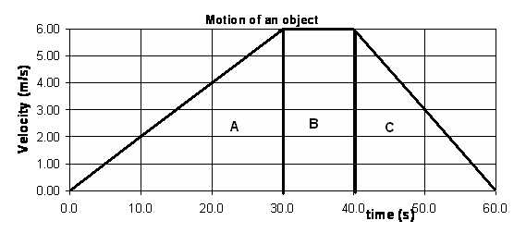
Calculate the displacement of the object. (4 marks)
displacement is area under the graph: Or
Area A = ½ x 30 x 6 = 90 [1 mark] A: 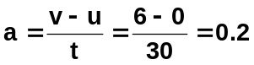 ms⁻²
Area B = 10 x 6 = 60 [1 mark] s = ut + ½ gt²
Area C = ½ x 20 x 6 = 60 [1 mark] = 0 + ½ x 0.2 x 30² = 90 m
B: s = vt = 6 x 10 = 60 m
displacement = 210 C: 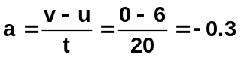ms⁻²
v² = u² + 2as
s = 2.10 x 10² m [1 mark] 0 = 6² + (2 x -0.3 x s)
-36 = -0.6s
s = 60 m s_{T} = 90 + 60 + 60
= 2.10 x 10² m
but why would you do it this way?

- a. Shane is on a sightseeing tour in a helicopter. When the helicopter is travelling downwards at 5.00 m s⁻¹, Shane looks out of the window and his 0.100 kg sunglasses fall off. If the glasses were 145 m above the ground when they fell off, with what velocity will the sunglasses hit the ground? (2 marks)

v² = u² + 2gs
u = 5.0 ms⁻¹ = (5²) + (2 x 9.8 x 145) [1 mark]
v = ? = 25 + 2842
m = 0.10 kg = 2867 = 53.544
s = 145 m v = 53.5 m s⁻¹ [1 mark]
g =9.8 ms⁻²

b. The glasses landed in long grass. If it took 0.400 s to stop, what force was applied to the sunglasses? (2 marks)

u = 53.5 ms⁻¹ F = m (v – u)
v = 0 t
t = 0.40 s F = 0.10 (0 – 53.544) [1 mark]
m = 0.10 kg 0.4
F = - 13.4 N
As need force on sunglasses, F = 13.4 N up [1 mark]

(student should put direction but don’t deduct marks if they
don’t, just warn them this time)
- Michael throws a 0.100 ball downwards with an initial velocity of 2.30 m s⁻¹. If the ball was 1.40 m above the ground when released what was its kinetic energy when it hit the ground?
(3 marks)

E_{T} = E_{k} + E_{p}
= (mgh) + (0.5 mv²)
= (0.1 x 9.8 x 1.4) + (0.5 x 0.1 x 2.30²) [1 mark]
= 1.372 + 0.2645
= 1.6365 J [1 mark]

now all of this is turned into E_{k}

so E_{k} = 1.64 J [1 mark]

- Red is on her way to her grandmother’s house. She follows the safe path which winds through the woods as shown below. The Wolf on the other hand, needs to get to grandmother’s house much quicker so that he is able to eat grandmother and catch Red. He goes straight through the woods following the shortest path possible. Red takes 30.0 minutes to get to grandmother’s house while the wolf takes only 10.0 minutes. Both start from the same place.
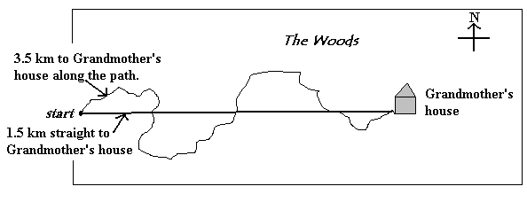
Using the information given, calculate Red’s velocity? (3 mark)

s = 1 500 m 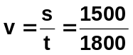 [1 mark]
t = 30 x 60 v = 0.833 m s⁻¹ [1 mark]
= 1800 s
[1 mark]


- Simon and Shaun are at the Royal Show on the bumper cars. The total mass of each car with rider is 170.0 kg. Simon is heading east towards Shaun at 3.50 ms⁻¹ and hits Shaun’s car head on. Simon’s car rebounds at 1.90 ms⁻¹ and Shaun’s car rebounds at 2.50 ms⁻¹. What was the initial velocity of Shaun’s car? (3 marks)

m₁u₁ + m₂u₂ = m₁v₁ + m₂v₂
(170 x 3.50) + (170 x u₂) = (170 x -1.90) + (170 x 2.50) [1 mark]
595 + 170u₂ = -323 + 425
170u₂ = -323 + 425 - 595
170u₂ = -493
u₂ = -2.90 ms⁻¹ [1 mark value]
Shaun’s car was initially travelling at 2.90 ms⁻¹ west [1 mark direction]

- On a flat, horizontal road, which pedal of the car is being used when
- the net force acting on the car is in the opposite direction as the car’s velocity
brake (1 mark) [1 mark]
- the net force and velocity are in the same direction?
accelerator (1 marks) [1 mark]
- Matthew is slowing down from a run as he has just passed the finish line in a 1.0 x 10² m sprint. On the diagram of Matthew, show the forces acting on him and label them appropriately.
(2 marks)

reaction force from ground
[1 mark arrows]
[1 mark labels]


friction forward force

NB: Forces up and down are equal but as slowing down forward force is less than
weight frictional forces.

- Victoria works in Coles doing night fill. She has to lift three 1.50 kg boxes of laundry detergent from the floor to the shelf 1.10 m above the floor. If it took 1.50 seconds to lift all boxes at once to the shelf, what power was required? (3 marks)
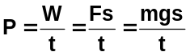
m = 3 x 1.5 [1 mark]
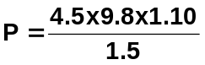 = 4.5 kg
s = 1.10 m
g = 9.8 ms⁻² [1 mark]
t = 1.5 s
P = 32.3 W [1 mark]

- A sand blaster is used to strip paint from a house. The sand blaster throws the sand against the wall with a velocity of 50.0 ms⁻¹, and it rebounds in the opposite direction at an average velocity of 8.00 ms⁻¹. Find the average force on the house if 0.200 kg hits it each second.
(3 marks)

u = 50.0 ms⁻¹ Ft = m(v – u)
v = -8.00 ms⁻¹ [1 mark] F x 1 = 0.2 (-8 – 50) [1 mark]
m = 0.2 kg F = -11.6 N
t = 1.0 s F = 11.6 N on the house [1 mark]

- Dangerous Dan is travelling along the road at a constant 90 kmh⁻¹ (unfortunately for Dan the speed limit is 60 kmh⁻¹). Dan’s car passes policeman Bob who on his stationary police bike just as Bob starts to accelerate his bike at 6.8 ms⁻² to catch Dan and book him. How far will the car travel before the police bike reaches it? (3 marks)

v = 90 kmh⁻¹
v = 25 ms⁻¹

s = vt s = ut + ½ at²
= 25 x t = 0 + ½ x 6.8 x t²
= 25t = 3.4t² [1 mark]
now both displacements are the same so
25t = 3.4t²
25 = 3.4t
t = 7.3529 s [1 mark]

s = 25t
= 25 x 7.3529
s = 184 m [1 mark]

